REPORT TITLE

By

Group C

Submitted to

The University of Liverpool

MASTER-OF-SCIENCE-TITLE

*Module-Name*

Word Count: XXX

{The Word Count does take into consideration all sections between the Introduction and Conclusions included. Please, do not include the amount of words used for references, title page, ToC, LoT, LoF.}

dd/mm/20xx

REPORT TITLE

Submitted to

The University of Liverpool

Word Count: XXX

dd/mm/20x

TABLE OF CONTENTS

Page

Chapter 1. Introduction 3

Chapter 2. Solution Design 4

2.1 Solution overview 4

2.2 Technical Flow 5

2.3 Solution Design (Client) 5

2.4 Solution Design (Server) 6

2.5 Design Decision 6

Chapter 3. Testing 6

3.1 Serialization Unit Testing 7

3.2 Encryption Unit Testing 7

3.3 Network Unit Testing 7

3.4 File Transfer Unit Testing 7

3.5 Decryption Unit Testing 7

3.6 De-Serialization Unit Testing 7

3.7 Integration Testing 7

Chapter 4. Conclusion 7

REFERENCES 8

APPENDICES 8

{To update the LIST OF FIGURES, right click on the entries, chose “Update Field”, choose “Update entire table” and click on OK}

# Introduction

*{This chapter introduces the Report, its aims and objectives, the IT artefact to be investigated, the problem, the question(s), approach and potential outcome.}*

# Solution Design

*{This chapter represents the main section of your report. It develops argument point by point, including the reasons that support the argument you declared in your introduction.)*

Solution overview

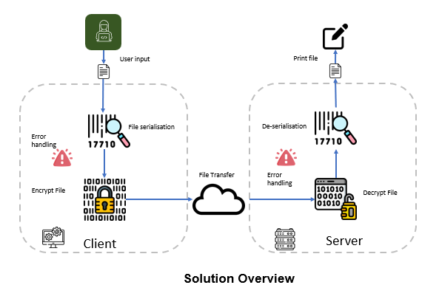

Figure 1. Solution overview

Technical Flow

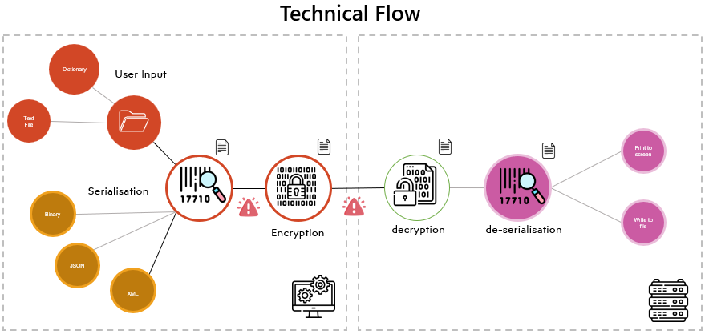

Figure 2. Technical Flow

Solution Design (Client)

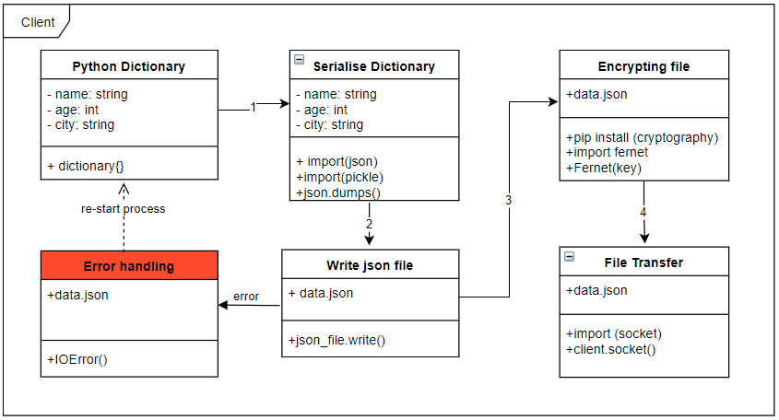

|  | **Description of activities** |
| --- | --- |
| 1 | User to input as Dictionary. |
| 2 | File is serialised using Pickle module JSON |
| 3 | File is encrypted using Cryptography modules Fernet Object |
| 4 | Token is generated to encrypt the file |
| 5 | Error handling will check if the file has been written |

Solution Design (Server)

|  | **Description of activities** |
| --- | --- |
| 1 | Server to listen to incoming calls |
| 2 | Server receives the file and decrypts |
| 3 | File is de-serialised |
| 4 | Received file is printed. |

Design Decision

|  | **Design decisions** |
| --- | --- |
| 1 | Agreed to use json formatting for serialisation since json is compact, concise and easier to read. |
| 2 | Fernet Object will be used for encrypting the file due to it’s simplicity and easy of use. Fernet is a symmetric encryption algorithm, meaning it uses the same key for both encryption and decryption |
|  |  |

# Testing

*{This final chapter serves as a summary of the project from a holistic perspective. It includes a critical review of the achievements and limitations of the project, from both an academic and business perspective. It includes suggestions for potential research in the future}*

Serialization Unit Testing

Encryption Unit Testing

Network Unit Testing

File Transfer Unit Testing

Decryption Unit Testing

De-Serialization Unit Testing

Integration Testing

# Conclusion

REFERENCES

{The purpose of a citation is to lead the reader to the correct reference entry. If it is a quote, the in-text citation includes the page of the quote so that the reader goes to the reference entry to access the source and then the page. Only sources actually cited are included in a reference section. You may have had other sources you read but ended up not citing. They are not included in the References listing.

This section includes all references cited, using the Harvard-style referencing format as described within the University Library portal.}

APPENDICES

|  | **Group Artifacts** |
| --- | --- |
| 1 | GitHub Repository |
| 2 | Client Server Network Project report |
| 3 | Requirement.txt |
| 4 | Readme.md |
| 5 | Log of Github code review |
| 6 | Log of Github push comments |